**Lesson 1:**

* Python Variables, Expressions, and Statements
* The concept of "value" and "type"
* Variables
* Variable names and keywords (reserved)
* Operators
* Operators and Operands
* Expressions
* Order of operations
* Urgent operations
* Data input
* Comments
* **Exercises**

**Note:**

**Statement:**

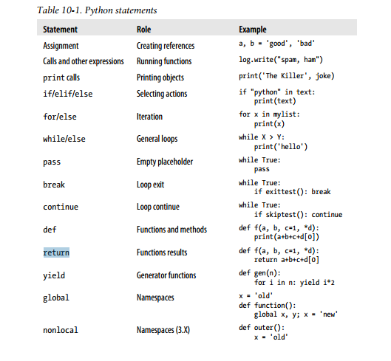

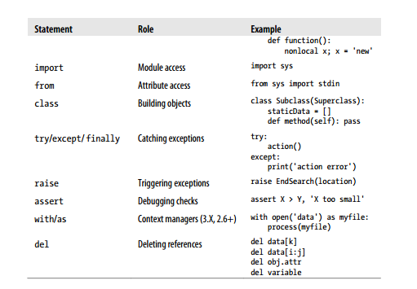

**Variable name rule:**

Syntax: (underscore or letter) + (any number of letters, digits, or underscores)

Variable names must start with an underscore or letter, which can be followed by

any number of letters, digits, or underscores. **_spam, spam**, and **Spam_1** are legal

names, but **1_Spam**, **spam$**, and **@#!** are not.

**Reserved words:**

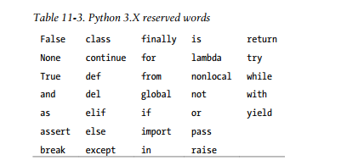

**Operators:**

[**https://www.w3schools.com/python/python_operators.asp**](https://www.w3schools.com/python/python_operators.asp)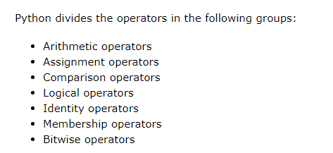

**Exercises**

**1. a** o’zgaruvchiga brorta string qiymat berilsin va bu qiymat ekranga 10 marta chiqarilsin.

**2.**Print qganda shu tartibda chiqsin:

“Hello World

Hello World

Hello World

Hello World”

3.Aylana yuzini hisoblash dasturini tuzing(S=2)

R ni qiymati o’zgaruvchiga saqlansin(Pi ni qiymati 3.14 deb olinsin).

4.Ism va Familya klaviaturadan kiritilsin va ekranga chiqarilsin(Bosh harflarda).

5.Yoshini hisoblash dasturi tuzilsin(Tug’ilgan yili klaviaturadan kiritiladi va yoshi ekranga chiqariladi)

6.Bror text klaviaturadan kiritilsin va uzunligi ekranga chiqarilsin.

7.Ism,tug’ilgan yili kiritilsin va ekranga Masalan:“Salom,Donyor,Sizning yoshingiz 20 da va siz 7300 kun yashadingiz” shunaqa formatda chiqarilsin.

8.Qoldiqni hisoblash dasturi tuzilsin.

9.Klavaituradan bror son kiritilsin u 100 dan kata yoki kichikligi tekshirilsin.

10.Klaviaturadan brorta harf kiritilsin va u “Hello World” textida bor yoki yo’qligi tekshirilsin.